**FORECASTING THE SALES OF A SUPERMARKET**

**ANJALI RATHORE**

**ABSTRACT-**

Most of the vendor, shopkeeper like to estimate the future trades. Many household products are sold by various shopkeepers of the retail store, stores are geographically located at various locations. Supply chain inefficiencies occurs, when market potential is not evaluated by the retailers. Many times it is not easy for retailers to understand and predict the market condition. Predicting system will help to

overcome the problem faced by the retailers as well as wholesellers of grocery stores. The aim of this project is to predict the future sales of the item according to the need of customer**. Demand forecasting is the process of making future estimates of customer demand over a specific period at a given price point, in a specific time frame and location.** Generally, demand forecasting considers historical data and other analytical information to produce the most accurate predictions. H**owever, in grocery retail, demand forecasting requires a granular approach to prediction — monthly, weekly, or daily forecasts to support various category management processes and supply chain decisions. Granular and adaptive forecasts are critical, given the wide spectrum of products varying from fresh to ambient products.**

**INTRODUCTION**

**Sales forecasting is a crucial part of the financial planning of a retail business, essentially is the process of estimating future business’s sales. A forecast is based on historical sales data and is done for a particular period of a time in the near future, usually the next calendar year. A**[**sales forecast**](https://citixsys.com/solutions/retail/ivend-analytics/ivend-analytics-detailed-feature-list/)**enables a company to make informed business decisions regarding inventory or cash flow or plan for growth.**

**It is for this reason, forecasting is a central activity in any**[**retail operations**](https://ivend.com/ivend-pos/)**. It is a self-assessment tool that uses past and current sales statistics to intelligently predict future performance.**

**Forecasting methods anticipate the future purchasing actions of consumers by evaluating past revenue and consumer behavior over the previous months or year to decipher patterns and develop forecasts for the upcoming months. Data is adjusted for seasonal trends, and then a plan for ordering and stocking products may follow the analysis. After fulfillment of current and forthcoming customer purchases and orders, an assessment of the results is compared with previous forecasts, and the entire procedure is repeated.**

**In retail management, forecasting serves to predict and meet the demands of consumers while controlling pricing and inventory. Holding excess inventory adds to overhead costs for a business whereas under stocking may lead to loss of revenue. Forecasting helps the retailer to meet the demands of the customer by understanding consumer purchase patterns better. It is also known to assist in more efficient use of shelf and display space within the retail establishment, in addition to optimal use of inventory space.A sales forecast is an expression of expected sales revenue.**

**A sales forecast estimates how much your company plans to sell within a certain time period (like quarter or year). The best sales forecasts do this with a high degree of A**CCURACY.

**RESEARCH BACKGROUND**

A.FUNDAMENTALS-

According to the search information Supermarket is a chain, with stores of all around the country and its current board set out a challenge to all the Data Scientist out there to help them create a model that can predict the Sales, Per-Product for each store. Store has collected the information of Sales data from previous year with the information owner hopes we can identify the products and this information helps them to take correct measures to ensure the success of their business.

B.CHALLENGES-

There are many challenges in the retail store network planning some of them are retailers fail in the evaluation of potential of the market. Many retailers, shopkeepers ignore the seasonal randomness. The inefficiencies, occurs in the supply chain when the products have great demand and they are not available. The retailers face the difficulties in inventory management system. Many of the time retailers ignore the competition in the market.

**DATA SOURCES**

Link to Dataset- <https://www.kaggle.com/datasets/aungpyaeap/supermarket-sales>

The Dataset has been acquired from kaggle , Which is provided by IBM Sales Department.

**LITERATURE SURVE**.

Sleek Bill-

Sleek bill is a simple and efficient Indian billing software which has been specially designed for the Indian market. The software assists in making your invoicing operations efficient. It is a fast and highly scalable solution which can be used to generate quick and detailed reports, backup/restore data, print/e-mail invoices, and perform GST calculations. Helps create GST compliant invoices along with the bill of supply with ease.

i.PROS

• It is easy to use and navigate

• It helps in the creation of standard invoices

• Provides good user experience

• Has a well-designed UI

• Provides excellent customer support

ii. Cons

• It has small fonts

• Receipts and reports can only be exported in limited formats such as excel.

**METHODOLOGY**

Holt in the year 1957 and Winters in year 1960 extended Holt’s method to capture the seasonality. The Holt-Winters seasonal prediction method comprises the forecast equation and three smoothing equations — one for the level ℓt, one for the trend bt, and one for the seasonal component st, with corresponding smoothing parameters α, β∗ and γ. We use m to denote the frequency of the seasonality, i.e., the number of seasons in a year. For example, for quarterly data m=4, and for monthly data m=12 There are two variations to this method that differ in the nature of the seasonal prediction. The additive method is chosen when the seasonal variations are constant through the series, while the multiplicative method is chosen when the seasonal variations are changing with the level of the series.

**Holt-Winters’ additive method**

The component form for the additive method is:

yt+h|t=ℓt+hbt+st+h−m(k+1)

ℓt=α(yt−st−m)+(1−α)(ℓt−1+bt−1)

bt=β∗(ℓt−ℓt−1)+(1−β∗)bt−1

st=γ(yt−ℓt−1−bt−1)+(1−γ)st−m,

where k =integer part of (h−1)/m,

(yt−st−m)=seasonal observation

(ℓt−1+bt−1)= Non seasonal prediction for time t.

(yt−ℓt−1−bt−1)=Average between current seasonal index and seasonal index of same season

The equation for the seasonal prediction is often expressed as

st=γ∗(yt−ℓt)+(1−γ∗)st−m

**Holt-Winters’ multiplicative method**

The component form for the multiplicative method is:

yt+h|t=(ℓt+hbt)st+h−m(k+1)

ℓt=αyt/st−m+(1−α)(ℓt−1+bt−1)

bt=β∗(ℓt−ℓt−1)+(1−β∗)bt−1

st=γyt/(ℓt−1+bt−1)+(1−γ)st−m

**PREDICTIVE PROCESS** 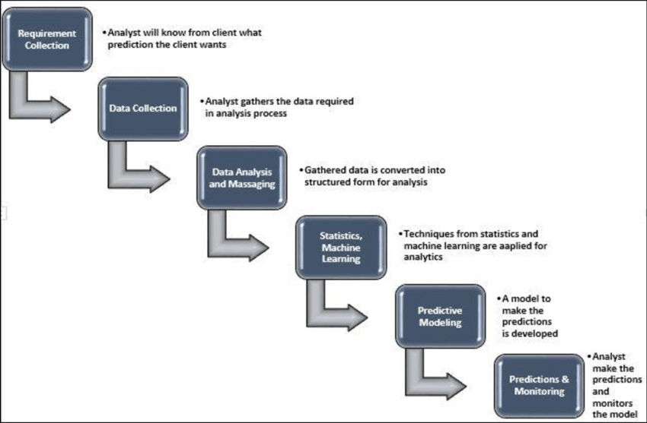

**CONCLUSION-**

From the analyzed data we obtain relevant data, we conclude that our proposed model gives the accurate predicted results to the grocery store about the sales, and future scope of product according to seasonal randomness. The predicted results are much more closer to the actual result which will increase the profit. This model can further be improved by working on Accuracy of Predicted result. Building a sales forecast is both an art and a science. Accurate sales forecasts keep your leaders happy and your business healthy.

**REFERENCES**

* Tripathi, Santosh Kumar. "GST Software in India."
* Mirajkar, Aishwarya Madan, Aishwarya Prafulla Sankpal, Priyanka Shashikant Koli, Rupali Anandrao Patil, and Ajit Ratnakar Pradnyavant. "Data mining based store layout architecture for supermarket." Int Res J Eng Technol 3 (2016).
* Catal, Cagatay, Ugur Sevim, and Banu Diri. "Practical development of an Eclipse-based software fault prediction tool using Naive Bayes algorithm." Expert Systems with Applications 38, no. 3 (2011): 2347-2353.
* Koehler, A.B., Snyder, R.D. and Ord, J.K., 2001. Forecasting models and prediction intervals for the multiplicative Holt– Winters method. International Journal of Forecasting, 17(2), pp.269-286.
* Singh, S.B., Tandon, R., Krishnamurthy, G., Vikram, R., Sharma, N., Basu, S.K. and Mukhopadhyay, A., 2003. Rab5‐mediated endosome–endosome fusion regulates hemoglobin endocytosis in Leishmania donovani. The EMBO journal, 22(21), pp.5712-5722.